
HMH | The lEARNING COMPANY

Math Alternative Text Specifications

Version History
DATE | CHANGES
10/25/2020 | Compiled from Habitat-specific and Learnosity specific guidelines

Contents

How to Use this Document 2
Purpose of Guidelines 3
Guiding Principles 3
Visual Bias 4
Best Practices for Items 4
2-D Shapes 5
3-D Shapes 6
Arrays 7
Bar Graphs 8
Base-Ten Blocks 9
Box-and-Whisker Plot 10
Circle Graphs or Pie Charts 11
Clocks 12
Compass Rose 13
Coordinate Planes – Points and Figures 14
Coordinate Planes – Lines 16
Fraction Models 17
Frames 18
Histograms 19
Line and Angle Relationships 20
Line Graphs 21
Line Plots and Dot Plots 22
Maps 23
Measuring Cups and Beakers 25
Money 26
Nets 27
Number and Hundreds Charts 28
Number Lines – General 29
Number Lines – Fractions and Decimals 30
Number Lines – Inequalities 31
Number Lines – Skip Counting 32
Patterns 33
Picture Graphs 34
Rulers 35
Scales 36
Scatter Plots 38
Scatter Plots (Cont.) 39
Spinners 40
Tables 41
Tally Charts 42
Thermometers 43
Venn Diagrams 44
Vertical Equations 45
How to Author Alt Text in CMS/Learnosity 46
How to Author Alt Text in CMS/Learnosity (Cont.) 48
How to Author Alt Text in Habitat 49
Embedded Math Notation 51
Contributions 55

How to Use this Document
The development of this document was created to be a useful reference tool in writing consistent alternative text for static images. It is intended to provide specifications for a large variety of images, symbols, numbers, and other illustrative interactions that could appear within any mathematics content or items.
When using this document to write alternative texts:
- Become familiar with the front matter of this document, which includes the purposes of the guidelines, guiding principles, information on visual bias, and best practices for items.
- Navigate to the page for the specific image type and refer to the general considerations section.
- Review the example images and alternative text provided for each image type. Use the examples as a general guide to writing the alternative text. Be sure to also analyze the item’s content and grade level to determine how these additional factors may impact the script.
- If numbers, equations, operations, and/or symbols are embedded within an image, refer to the Embedded Math Notation section for best practices on providing the appropriate alternative text.
- Consult the How to Author Alt Text section to view step-by-step instructions on how to enter alternative text in CMS/Learnosity or Habitat.

Purpose of Guidelines

At HMH, text alternatives (also known as alt text) must be pedagogically sound to be considered sufficient for accessibility.
Before now, text alternatives could be a sentence fragment conveying the minimum objective description necessary to understand that there's an image present - like "Apple on table" or "Two dogs."
But today, we write pedagogical text alternatives: content that re-creates meaning and relevance for learning purposes.
Text alternatives may be as recognizable as video closed-captioning or as subtle as a well-written manuscript--carried in the alt-text attribute--that blends into the content surrounding it. As a rule, think of your text alternatives as an accommodation in assuring equity and accessibility for all learners. Provide the information that they need to understand what is happening in the image and do your best to fit the text alternative in the context of the text that comes before and after it.
The recommendations in this document are not intended to be inflexible, but rather to guide the development of creating text alternatives.

Guiding Principles

Consider the following best practices when writing alternative text for students who have an accommodation.

- Brevity: Keep descriptions brief. Listening to a long alternative text description can create an unnecessary burden for learners and require greater short-term memory effort.

- Clarity: Create alternative text descriptions that are clear, precise, and straightforward. If the image description needs to be listened to several times, the script may lack clarity or be too complex.

- Drill-Down Organization: Begin with a brief summary description followed by more specific data when necessary. Present information in a logical order.

- Validity: Determine if it is necessary to describe the entire image. If details within the image are not specifically needed to answer the question or understand the concept, it may be sufficient to provide just a general description of the image.

- Language Complexity: Use simple, grade-level appropriate and subject-specific language in all descriptions. Incorporate language and vocabulary from the item’s text when appropriate.

- Consistency: Provide image descriptions that are consistent within and across items types to ensure a similar user experience. Make certain that alternative text is comparable in terms of sentence structure, language usage, and length.

Visual Bias
An item has visual bias if:

- a visual understanding of the assessed concept is needed to complete the task.

- the assessed skill violates the construct being measured.

- the alternative text would cause a cognitive overload in order to keep track of the
given information.

- an image requires a tactile representation.

- the image description would cue the correct answer.

- a complex explanation or above grade level vocabulary is needed to accurately
describe the image.

Images with visual bias should be scripted with a general description of the image and this boilerplate: “For more information, ask for help.”

Best Practices for Items

  - Do not provide alternative text for content other than what appears within an image. The screen reader functionality is designed to provide a script for text in stems, prompt questions, and/or distractors.

  - If providing the alternative text cues the answer, only provide a general description of the image (e.g., “A net is shown.”).

  - Be mindful about punctuation usage in the description. End each statement with a period to ensure a pause is inserted before moving on to the next statement. Commas and colons will also be read as pauses of slightly different lengths.

  - Ensure that no two alternative texts are identical in an item since this interferes with the ability to access the item’s content.

  - If multiple pieces of art within the stem or distractors of an item have identical characteristics, consolidate the descriptions into an introductory sentence(s) beginning with the first piece of art for which script is being provided.

  - Do not insert details into the alternative text that pertain to color unless it is mathematically necessary.

  - When writing alternative text for choices in multiple choice items, do not script the answer choice letters (e.g., A, B, C, D, etc., should not be scripted).

  - Do not provide alternative text for any technology enhanced item functionality, such as dragging art into an interactive table or plotting points on an interactive coordinate plane.

2-D Shapes

Description of Image: Two dimensional shapes are simple figures that have length and width, but lack depth. These geometric shapes are sometimes described as being “flat.”
General Considerations:
- Give the name of the shape or describe the shape’s attributes.
- Specify any labels or dimensions if present.
- If providing a script requires a complex explanation or above grade-level vocabulary, the item has visual bias and should not be scripted.
- Note: Many shapes will contain visual bias. Do not script if it violates the construct being measured.

Example Alt Text 1: Example Alt Text 2:
What is the height, h, of the isosceles triangle below to the nearest inch?
Which shape is a square?

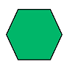
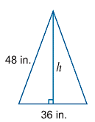
A.

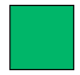
B.

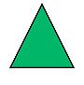
Enter the answer in the box.

C.

Example Alt Text 1: Example Alt Text 2:
A. A shape with six sides is shown. All of the sides are the same length.
B. A shape with four sides is shown. All of the sides are the same length.
C. A shape with three sides is shown. All of the sides are the same length.

An isosceles triangle is shown. The base of the triangle is labeled thirty-six inches. One of the sides is labeled forty-eight inches. A line drawn for the height divides the isosceles triangle into two similar right triangles. The height of the triangle is labeled h.



3-D Shapes

Description of Image: Three dimensional shapes are figures that have length, width, and height. These geometric shapes are sometimes referred to as “solids.”
General Considerations:
- Give the name of the shape or describe the shape’s attributes.
- Specify any labels or dimensions if present.
- If providing a script requires a complex explanation or above grade-level vocabulary, the item has visual bias and should not be scripted.
- Note: Many shapes will contain visual bias. Do not script if it violates the construct being measured.

Example Alt Text 1: Example Alt Text 2:
Which of these is a cube?

Amelia filled $\frac{1}{8}$ of her new aquarium with gravel.

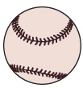
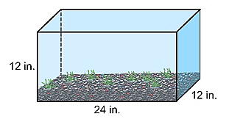
A.

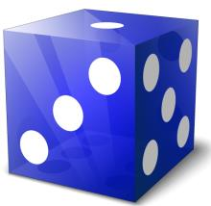
B.

How much gravel did Amelia use?
A. 162 ${in.}^{3}$
B. 180 ${in.}^{3}$
C. 216 ${in.}^{3}$
D. 432 ${in.}^{3}$

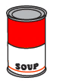
C.

Example Alt Text 1: Example Alt Text 2:
- A shape that is round with one curved side.

- A shape with six flat sides and no curves.

- A shape with a round flat bottom, a round flat top, and one curved side.

A rectangular prism is shown. The height of the rectangular prism is labeled twelve inches. The length is labeled twenty-four inches. The width is labeled twelve inches.



Algebra Tiles
Description of Image: Algebra tiles are two-color square and rectangular mathematical manipulatives used to represent numbers and variables while modeling algebra problems. Like two-color counters, one side of each tile is yellow, indicating a positive value, and the other side is red, indicating a negative value.
General Considerations:
- Use large cube, rectangle, and small cube to describe the size and shape of the tiles.
- Do not include the colors of the tiles, but do specify whether each tile is positive or negative.
- Do not script if doing so will violate the construct being measured.
Example Alt Text:

The algebra tile diagram shows a product with binomial factors.

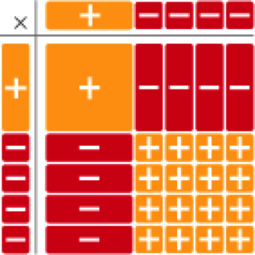

Represent the diagram as a product of binomial factors and as a polynomial in standard form.

Example Alt Text:

Algebra tiles in a multiplication table. The top factor has 1 positive rectangular tile and 4 negative small square tiles. The side factor has 1 positive rectangular tile and 4 negative small square tiles. The product is arranged in 5 rows. Row 1: 1 positive large square tile and 4 negative rectangle tiles. Rows 2 through 5 each have: 1 negative rectangle tile and 4 positive small square tiles.

Arrays

Description of Image: An array is a visual representation which organizes same-sized squares or objects in rows and columns. Arrays are used to model concepts such as repeated addition, multiplication, and ideas about even and odd numbers.
General Considerations:
- Provide the title if one is present.
- Give a general description of the array. List the number of rows first followed by the number of columns.
- Use the word grid when describing the dimensions of a rectangular array (e.g., “A ten by ten grid is shown.”).
- Explain the number of boxes shaded in a rectangular array if necessary for problem solving.
- Do not give the total number of objects or parts since this violates the construct being measured.

Example Alt Text 1: Example Alt Text 2:
How many same-sized squares?

How many flowers are shown?

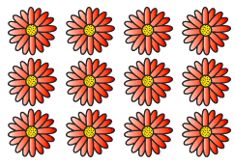
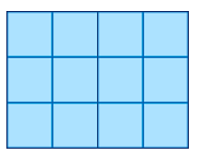

A. 11
B. 12
C. 13

A. 11
B. 12
C. 13

Example Alt Text 1: Example Alt Text 2:
A three by four array of flowers is shown. A three by four array is shown.

Bar Graphs

Description of Image: Bar graphs are visual displays which use either vertical or horizontal bars to represent categorical and numerical data.
General Considerations:
- Provide the title first if present.
- Give the x-axis label followed by the range and scale if applicable. Then give the y-axis label followed by the range and scale if applicable. (For grades K-4, refer to the x-axis as the horizontal axis and refer to the y-axis as the vertical axis.)
- Specify the category and the actual value of each bar. However, do not script when the expectation is to find the value of a category.
- Explain the position of the data bars when data lands between two values (e.g., “halfway between 7 and 8”).
- Do not include the colors of the bars unless necessary for problem solving.
- If construct violates the content being measured, script as, “A bar graph is shown.”

Example Alt Text:
Kayla made this graph to show her friends’ favorite kinds of movies.
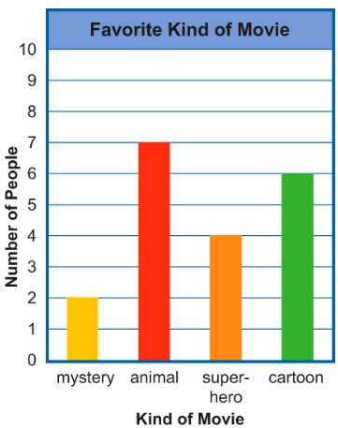

How many more friends like cartoons than mysteries?
A. 2
B. 4
C. 6

Example Alt Text:

The bar graph is titled Favorite Kind of Movie. The horizontal axis is labeled Kind of Movie and lists four kinds movies. The vertical axis is labeled Number of People and goes from zero to ten. Mystery, two. Animal, seven. Super Hero, four. Cartoon, six.

Base-Ten Blocks

Description of Image: Base-ten blocks are 3-D mathematical manipulatives used to model basic concepts such as number sense, place value, counting, and the four operations with numbers.
General Considerations:
- Use one-thousand-cube to describe a group of 1,000 cubes.
- Use one-hundred flat to describe a group of 100 cubes.
- Use ten-cube rod to describe a group of 10 cubes.
- Use unit cube to describe an individual cube.
- Do not include the colors of the blocks unless necessary for problem solving.
- Do not script if doing so will violate the construct being measured.

Example Alt Text:
What number is shown in this visual model?

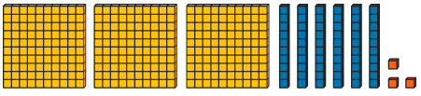

A. 336
B. 363
C. 636

Example Alt Text:

Three one-hundred flats, six ten cube rods, and three unit cubes are shown.

Box-and-Whisker Plot

Description of Image: A box-and-whisker plot (also known as a box plot) is a statistical graph that shows the distribution of a data set using the minimum, first quartile, median, third quartile, and maximum.
General Considerations:
- Provide the title and/or x-axis label if present.
- Consider the question presented in the stem to determine what information must be included in the image description.
- Identify the range of the number line, the whiskers, and the box.
- Give a general description of how the box is divided when scripting for the median. Do not give the exact value of the median.

Example Alt Text:
The box plot below shows the number of ice cream flavors sold at different ice cream shops throughout a city.

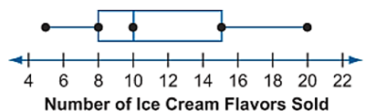

What is the median number of flavors sold at these ice cream shops?
A. 8
B. 10
C. 13
D. 15

Example Alt Text:

The box plot is titled Number of Ice Cream Flavors Sold. The number line goes from four to twenty-two by a scale of two. The whiskers range from five to twenty ice cream flavors sold, and the box ranges from eight to fifteen ice cream flavors sold. A line divides the box at ten flavors.

Circle Graphs or Pie Charts

Description of Image: Circle graphs or pie charts are visual displays of data in which a circle is divided into slices that represent a proportion of the whole. Each slice signifies a category of data and shows the relative size of the data as a numerical value or percentage.
General Considerations:
- Provide the title if present and a general description of how the circle is divided, including the number and relative size of the sections (i.e., whether the sections are equal or unequal).
- Give the category and data value of each section in a clockwise direction starting at the noon hour in relation to a clock.
- Do not include the colors of the sections unless necessary for problem solving.
- Do not script when the expectation is to find the value of a single category.
- If construct violates the content being measured, script as, “A circle graph is shown.”

Example Alt Text:
Students have the choice of 5 different lunches. The circle graph shows the number of students who chose each lunch.

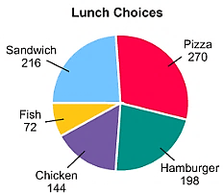
How many more students chose chicken than fish?
A. 2
B. 4
C. 6

Example Alt Text:
A circle graph is titled Lunch Choices. It is divided into five unequal parts. Pizza, two hundred seventy. Hamburger, one hundred ninety-eight. Chicken, one hundred forty-four. Fish, seventy-two. Sandwich, two hundred sixteen.

Clocks

Description of Image: Analog clocks indicate time using numbers, clock hands, and sometimes tick marks that represent each minute. Digital clocks display time using numbers and a colon between the hours and minutes.
General Considerations:
- Use short and long when referring to the hands of an analog clock.
- Use between when the short hands fall between two hour hands on an analog clock.
- Use colon when scripting a digital clock.
- When the construct being assessed is not related to telling time, give the spoken time (e.g., six forty-five).

Example Alt Text 1: Example Alt Text 2:
Rafael is finishing his homework in the evening. His clock shows this time.

Which clock shows 15 minutes before 7:00?

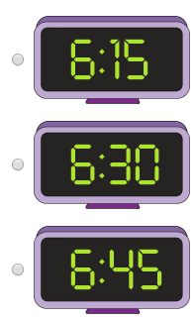
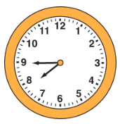
A.

B.

C.

What time is shown on the clock?

Example Alt Text 1: Example Alt Text 2:
- A digital clock shows six colon one five.

- A digit clock shows six colon three zero.

- A digital clock shows six colon four five.

A clock shows the short hand is a little more than halfway between the seven and the eight. The long hand points to the nine.

Compass Rose

Description of Image: A compass rose is a tool used on maps, charts, and coordinate planes to indicate the orientation of the cardinal and intermediate directions.
General Considerations:
- Indicate that a compass rose is shown when present in items.
- Only describe the direction that the letter N is pointing by using up, to the right, down, or to the left.
- Do not script the actual names of the cardinal or intermediate directions.

Example Alt Text:
A rabbit left its cage at (5, 6) and hopped 2 units east and 3 units south.

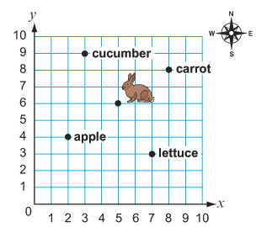

Which food did the rabbit find?
A. apple
B. carrot
C. cucumber
D. lettuce

Example Alt Text:

A first quadrant coordinate plane is shown. A compass rose is given with the N pointing up. The rabbit is located at five comma six. A cucumber is at three comma nine. A carrot is at eight comma eight. Lettuce is at seven comma three. An apple is at two comma four.

Coordinate Planes – Points and Figures

Description of Image: A coordinate plane is defined by the perpendicular intersection of a horizontal number line (x-axis) with a vertical number line (y-axis) at the point (0, 0) or the origin. The locations of points in a coordinate plane are given using an ordered pair of numbers in the form of (x, y) where x represents the x-coordinate and y represents the y-coordinate.
General Considerations:
- Indicate that a coordinate plane is shown and specify the number of quadrants.
- Provide the location of each plotted point or the location of each vertex of a graphed figure.
- If giving the exact location of the labeled points or vertices violates the content being measured, describe the points in relation to the origin instead of the axes.
- Read plotted points from left to right. Read vertices of graphed figures from left to right in a clockwise direction around the figure.
- Do not script the name of a graphed figure if it violates the construct being measured.
Example Alt Text 1: Example Alt Text 2:
What is the length of $\overline{CD}$ in the triangle graphed on the coordinate plane below?

Which point on the coordinate plane below is located at (6, 3)?

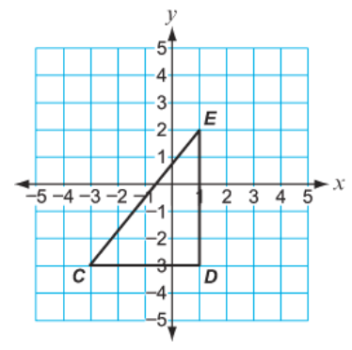
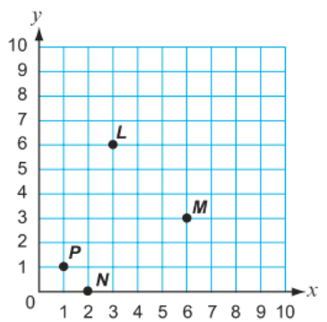

A. L
B. M
C. N
D. P
A. 2 units
B. 3 units
C. 4 units
D. 5 units

Example Alt Text 1: Example Alt Text 2:

A four quadrant coordinate plane is shown. Triangle C E D is graphed. Point C is at negative three comma negative three. Point E is at one comma two. Point D is at one comma negative three.
A first quadrant coordinate plane is shown. Four points are plotted. Point P is one unit right from the origin and one unit up from the origin. Point N is two units right from the origin and on the x-axis. Point L is three units right from the origin and six units up from the origin. Point M is six units right from the origin and three units up from the origin.

Coordinate Planes – Lines

Description of Image: A coordinate plane is defined by the perpendicular intersection of a horizontal number line (x-axis) with a vertical number line (y-axis) at the point (0, 0) or the origin. Coordinate planes can be used to graph the relationships of lines and functions.
General Considerations:
- Indicate that a coordinate plane is shown and specify the number of quadrants.
- Only provide the range and scale of the x- and y-axes when necessary.
- Describe the shape, position, and any special features of each line.
- Specify the coordinates of the x- and y- intercepts from left to right on the graph.
- Do not script certain features of the lines (e.g., intercepts, point of intersection, slope, equation, etc.) when the construct violates the content being measured.

Example Alt Text:
What is the solution to the system of equations shown in the graph below?

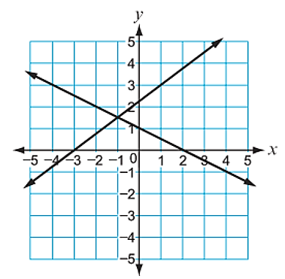

Enter the correct answer in the box.

Example Alt Text:

A four quadrant coordinate plane is shown. Two intersecting lines are graphed. A straight line passes through the points negative three comma zero and zero comma two. Another straight line passes through the points zero comma one and two comma zero.

Fraction Models

Description of Image: Fraction models are visual representations of fractions, including improper fractions, mixed numbers, decimals, and percents. These models are typically squares, rectangles, or circles divided into same-sized parts which are shaded to represent a specified fraction. Fraction models can also be used when performing any of the four operations with fractions or decimals.
General Considerations:
- Provide a description of the shape and how it is divided.
- Only describe color or shading when it is necessary for problem solving.
- Do not give the total number of parts or use terms that violate the construct being measured (e.g., “Three of four parts are shaded.”).
- Do not provide a script when the expectation is to identify the number of shaded parts.

Example Alt Text 1: Example Alt Text 2:
Which fraction is equivalent to the shaded portion of the shape?

Which expression represents the shaded parts of the visual model?

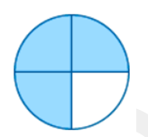
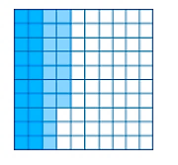

A. $\frac{4}{16}$
B. $\frac{12}{16}$
C. $\frac{7}{8}$
D. $\frac{12}{4}$
A. 0.02 $+$ 0.17
B. 0.2 + 0.17
C. 0.02 + 0.017
D. 0.2 + 1.7

Example Alt Text 1: Example Alt Text 2:
A ten by ten grid is shown. The first two columns are shaded dark blue. The third column and seven boxes in the fourth column are shaded light blue.

A circle is divided into four equal parts. Three parts are shaded.

Frames

Description of Image: A frame is a visual arrangement of boxes that provide an anchor for thinking about and working with the landmark numbers 5, 10, and 20. Frames look similar to arrays and are used to model concepts such as number sense, counting, and basic operations with numbers.
General Considerations:
- Provide a general description of the frame.
- Explain how the frame is occupied by giving the structure of the dots (i.e., shape and shading) in the top row and then the bottom row.
- Only describe the color of the shading when it is necessary for problem solving.
- Do not script the arrangement and configuration of dots if it violates the construct being measured (e.g., when the item is assessing the structure of numbers).

Example Alt Text:
Micah has some blue counters and some white counters.

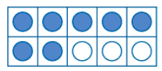

What equation can Micah write about his blue and white counters?
A. 7 + 3 = 10
B. 6 + 4 = 10
C. 5 + 5 = 10

Example Alt Text:

A ten frame is shown. The top row shows five blue counters. The bottom row shows two blue circles and three white counters.

Histograms

Description of Image: A histogram is a statistical graph used to represent the frequency distribution of numerical data. Different from a bar graph, histograms represent a large data set and groups information into equal intervals or ranges.
General Considerations:
- Provide the title first followed by the x-axis label, range, and scale. Then give the y-axis label, range, and scale.
- Give the interval and actual value of each bar. However, do not script when the expectation is to find the value of a bar or interval.
- When a bar lands between two values on the graph, explain the approximate location of the data using general language, such as just above, just below, or midway between.
Example Alt Text:
The histogram below shows the number of pushups Coach Price’s athletes completed during a fitness test.

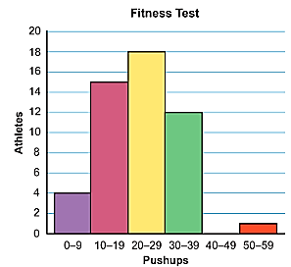
Number of Athletes
Number of Athletes
Number of Pushups
Number of Pushups
Which statement about the data is true?
A. Most athletes completed fewer than 20 pushups
B. A total of 5 athletes completed pushups during the fitness test.
C. There were more than 50 athletes that completed the fitness test.
D: The most common number of pushups completed was between 20 and 29.

Example Alt Text:
The histogram is titled Fitness Test. The x-axis is labeled Number of Pushups and goes from zero to fifty-nine in intervals of nine pushups. The y-axis is labeled Number of Athletes and goes from zero to twenty by a scale of two. The bar for 0 to 9 is at four. The bar for 10 to 19 is at fifteen. The bar for 20 to 29 is at eighteen. The bar for 30 to 39 is at twelve. The bar for 50 to 59 is at one.

Line and Angle Relationships

Description of Image: Line and angle relationships are often modeled using diagrams to explore and apply the properties of lines which result in special angle relationships.
General Considerations:
- Give a general explanation of what the diagram shows by describing the lines and/or angles.
- Specify the names, labels, and measurements of the lines and angles if present.
- Provide all information necessary for problem solving.
- Do not script certain characteristics of the lines or angles when the construct violates the content being measured.
- If providing a script requires a lengthy or complex explanation, the item has visual bias and should not be scripted.

Example Alt Text 1: Example Alt Text 2:
Natalia draw a straight angle. She then draws a ray to divide it into two angles.

In the diagram below, parallel lines a and b are intersected by line x.

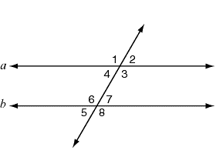
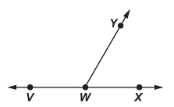
x

Angle VWY measures 120°. What is the measure of angle XWY?

A. 30°
B. 60°
C. 120°
D. 240$°$

If m$∠$ = 120°, what is m∠3?
A. 60°
B. 90°
C. 120°
D. 180$°$

Example Alt Text 1: Example Alt Text 2:
Straight angle V W X is shown. Ray W Y divides the straight angle into angle V W Y and angle X W Y.

A diagram shows parallel lines a and b are intersected by line x. Where line x intersects line a, four angles are created. The angles are labeled clockwise from the upper left: angle one, angle two, angle three, angle four. Where line x intersects line b, four angles are created. The angles are labeled clockwise from the upper left: angle six, angle seven, angle eight, angle nine.

Line Graphs

Description of Image: Line graphs are visual displays of data in which the relationship between two variables is graphed as individual data points connected by a line on a coordinate plane.
General Considerations:
- Provide the title first followed by the x-axis label, range, and scale. Then give y-axis label, range, and scale.
- Identify where the graph of the line begins and describe the shape and position of the line.
- If a linear or proportional relationship is shown (i.e., a straight line), specify 1-2 points that the line passes through on the graph. However, do not script the points if doing so cues the correct answer.
- If a non-linear relationship is shown with less than ten points graphed, describe the individual points as long as it does not cause a cognitive overload.
- If construct violates the content being measured, script as, “A line graph is shown.”

Example Alt Text:
The graph shows a proportional relationship between the number of pounds of watermelon, x, and the total cost in dollar, y.

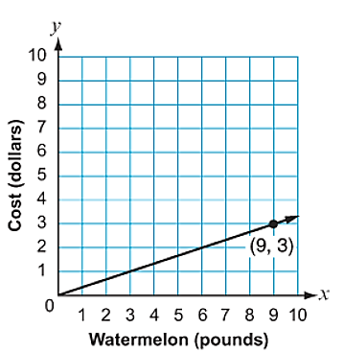
Cost of Watermelons

What does the point (9, 3) represent?
A. It costs $1 for 3 pounds of watermelon.
B. It costs $3 for 9 pounds of watermelon.
C. It costs $9 for 3 pounds of watermelon.
D. It costs $9 for 9 pounds of watermelon.

Example Alt Text:
The line graph is titled Cost of Watermelons. The x-axis is labeled Watermelons in pounds and goes from zero to ten by a scale of one. The y-axis is labeled Cost in dollars and goes from zero to ten by a scale of one. A straight line that begins at the origin and passes through the points (3, 1) and (9, 3) is graphed.

Line Plots and Dot Plots

Description of Image: Line plots and dot plots are statistical graphs that show the frequency and distribution of data on a number line. Each piece of data is represented with either an X or a dot plotted above the values along a number line.
General Considerations:
- Provide the title and/or x-axis label if present.
- Describe the number line by providing the range of numbers and scale.
- If a number line uses negative values, specify whether the value is negative or positive when providing the range.
- If the construct being measured contains fractions or decimals, describe how the number line is divided.
- Describe the data for each value on the number line. If providing a script cues the answer, the item has visual bias and should not be scripted.
- Do not script for values on the number line without data associated (e.g., “Zero dots at five days,” should not be scripted).
Example Alt Text:
Sara asked a group of students how many days they went swimming last week. She recorded the results in the dot plot below.
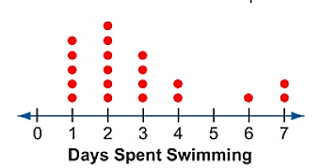

How many students did Sara ask?
A. 6
B. 7
C. 20
D. 23

Example Alt Text:
The dot plot is titled Days Spent Swimming. The number line goes from zero to seven days. Five dots above one day. Six dots above two days. Four dots above three days. Two dots above four days. One dot above six days. Two dots above seven days.

Maps

Description of Image: A map is diagram of an area that is used to represent the location of places or objects in relation to one another.
General Considerations:
- Provide the title if one is given and give a general description of what the map shows.
- Explain any features of the map that are necessary for problem solving (e.g., plotted points/locations, labels, measurements, the compass rose, scale, etc.).
- Consider the question presented in the stem to determine what information must be included in the image description.
- If construct violates the content being measured, script as, “A map is shown.”

Example Alt Text:
The map below shows part of a train route that connects three train stations.

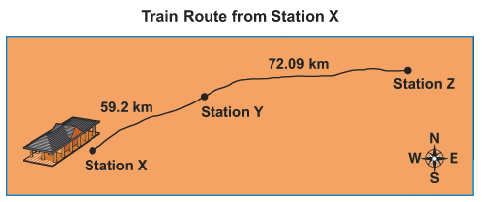

Which equation is a reasonable estimate of the total number of kilometers from Station X to Station Z?

A. 50 + 100 = 150

B. 75 – 50 = 25

C. 60 + 70 = 130

D. 70 – 60 = 10

Example Alt Text:

The map is titled Train Route from Station X. There are three points on the map that are labeled Station X, Station Y, and Station Z. The distance between Station X and Station Y is labeled fifty-nine and two tenths kilometers. The distance between Station Y and Station Z is labeled seventy-two and nine hundreds kilometers.

Measuring Cups and Beakers

Description of Image: Measuring cups and beakers are graduated containers or jars typically used to measure the volume of liquids or dry ingredients.
General Considerations:
- Use the language from the stem or prompt question if possible (e.g., measuring cup, beaker, jar, etc.).
- Provide the range and scale of the measurements on the container.
- Describe the actual measurement of the contents in the container.
- If the measurement falls between two values, give the approximate location of the measurement and specify that it is an estimate.
- Do not script if doing so will violate the construct being measured.

Example Alt Text:
A science teacher poured 750 milliliters (mL) of water into a beaker. She then used 150 ml of the water for an experiment. Which beaker shows how much water the teacher had left?

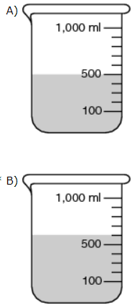
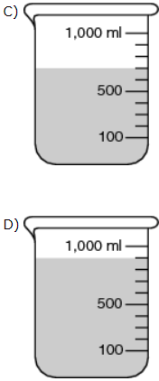
C.

D.

A.

B.

Example Alt Text:
A. Four beakers are shown. Each beaker goes from zero to one thousand milliliters. There are four marks between one hundred and five hundred milliliters. There are five marks between five hundred and one thousand milliliters. The first beaker shows the water at the mark for five hundred milliliters.
B. The water is shown at the mark just above five hundred milliliters.
C. The water is shown at two marks above five hundred milliliters.
D. The water is shown at the line just below one thousand milliliters.

Money

Description of Image: Money is sometimes visually represented using realistic bills and coins.
General Considerations:
- Coins should be scripted as quarter, dime, nickel, penny, etc.
- If the coin prominently displays the monetary value, provide the value followed by the word coin (e.g., twenty-five cent coin, one cent coin, etc.).
- Bills should be scripted as twenty-dollar bill, five-dollar bill, one-dollar bill, etc., unless it violates the construct being measured.
- Do not provide a script if the expectation is to identify the coin(s).
- If construct violates the content being measured, script as, “Coins (or bills) are shown.”

Example Alt Text 1: Example Alt Text 2:
What is the total amount of money shown?
Marco wants to buy a bottle of juice for $0.74. Which shows the exact amount Marco needs to buy the bottle of juice?

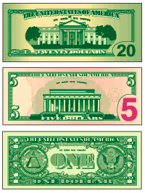

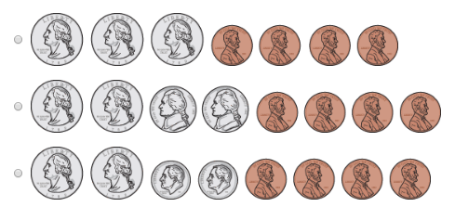

A. $20

B. $25

C. $26

Example Alt Text 1: Example Alt Text 2:
- Three quarters, four pennies.

- Two quarters, two nickels, and four pennies.

- Two quarters, two dimes, and four pennies.

Paper money is shown. One twenty-dollar bill, one five-dollar bill, and one one-dollar bill.

Nets

Description of Image: A net is two-dimensional representation of a three-dimensional shape, which is often used to model the concepts of surface area and volume.
General Considerations:
- Give the name of the 3-D shape or describe the shapes that make up the net.
- Specify any labels or dimensions if present.
- Do not script items if the expectation is to compose or identify a 3-D shape from a 2-D image or vice versa.
- If providing a script requires a complex explanation or above grade-level vocabulary, the item has visual bias and should not be scripted.
- Note: Many shapes will contain visual bias. Do not script if it violates the construct being measured.

Example Alt Text:
Jenny plans to make a gift box using the net of the square pyramid below.

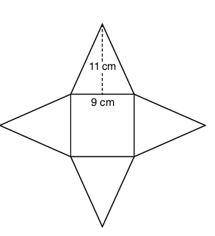

How many square centimeters of cardboard does Jenny need to make the box?
A. 125 ${cm}^{2}$
B. 198 ${cm}^{2}$
C. 279 ${cm}^{2}$
D. 477 ${cm}^{2}$

Example Alt Text:

The net of a square pyramid is shown. The length of the side of the square is labeled nine centimeters. The base of one of the triangular sides is labeled nine centimeters and its height is labeled eleven centimeters.

Number and Hundreds Charts

Description of Image: A number or hundreds chart provides a visual framework for a given number range within the base-ten system. These charts are typically arranged in a grid with numbers printed inside of the squares.
General Considerations:
- Provide the range of the numbers.
- Specify whether any of the numbers are shaded or circled.
- If the chart includes blank spaces, include a description of the numbers both in front of and behind the missing number.
- Describe any additional arrows, jumps, hops, or loops that might indicate counting, adding, or subtracting.

Example Alt Text:
Which equation does this hundreds chart show?

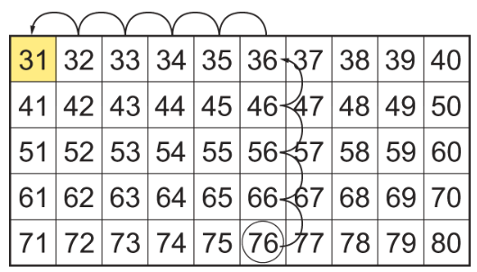

A. 36-40 = 31
B. 76-35 = 31
C. 76-45 = 31

Example Alt Text:

A number chart shows the numbers thirty-one to eighty. The number seventy-six is circled, and the number thirty-one is shaded. A loop begins at seventy-six and jumps backward to sixty-six, fifty-six, forty-six, and thirty-six. Then it the jumps backwards from thirty-six to thirty-five, thirty-four, thirty-three, thirty-two and thirty-one.

Number Lines – General

Description of Image: Number lines are visual representations of real numbers on horizontal or vertical lines marked at equal intervals. Number lines are used to model number sense and relationships, which are often represented by plotted points.
General Considerations:
- Provide the title and/or x-axis label if present.
- Describe the number line by providing the range of numbers, scale if necessary, and the location of any plotted points listed from left to right.
- If a number line uses negative values, specify whether the value is negative or positive when providing the range of the x-axis.
- If a point falls between two values, give a description of the approximate location.
- If giving the exact location of labeled points violates the content being measured, provide a general script instead (e.g., “Four points labeled A, B, C, and D are plotted on the number line.”).

Example Alt Text:
Which point represents the opposite of point Y on the number line below?

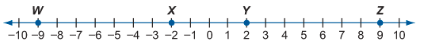

A. W
B. X
C. Y
D. Z

Example Alt Text:

A number line is shown. The number line goes from negative ten to positive ten by a scale of one. Four points are plotted on the number line. Point W, negative nine. Point X, negative two. Point Y, positive two. Point Z, positive nine.

Number Lines – Fractions and Decimals

Description of Image: Number lines are visual representations of real numbers on horizontal or vertical lines marked at equal intervals. Number lines can use whole numbers, fractions, and/or decimals to model number sense and relationships.
General Considerations:
- Provide the title and/or x-axis label if present.
- Describe the number line by providing the range of numbers and scale if necessary.
- If a number line uses negative values, specify whether the value is negative or positive when providing the range.
- If the construct being measured contains fractions or decimals, describe how the number line is divided (e.g., “Marks divide the space between each number into four equal parts.”).
- If fraction or decimal sense is not the construct being measured, describe the parts by using fractions (e.g., “Marks divide the space between each number into fourths.”).
- If giving the exact location of labeled points violates the content being measured, provide a general script instead (e.g., “Four points labeled A, B, C, and D are plotted on the number line.”).

Example Alt Text:
Which number line plots a point at $\frac{2}{3}$?

?
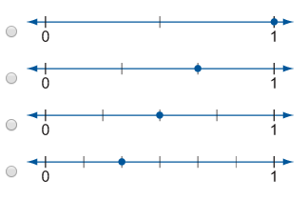
A.

B.

C.

D.

Example Alt Text:

- Four number lines are shown. Each number line goes from zero to one. The first number line shows marks that divide the space between each number into two equal parts. A point is plotted on the mark for one.

- Marks divide the space between each number into three equal parts. A point is plotted on the second mark to the right of zero.

- Marks divide the space between each number into four equal parts. A point is plotted on the second mark to the right of zero.

- Marks divide the space between each number into six equal parts. A point is plotted on the second mark to the right of zero.

Number Lines – Inequalities

Description of Image: Number lines are visual representations of real numbers on horizontal or vertical lines marked at equal intervals. Number lines can be used to model number sense and relationships.
General Considerations:
- Provide the title and/or x-axis label if present.
- Describe the number line by providing the range of numbers and scale if necessary.
- If a number line uses negative values, specify whether the value is negative or positive when providing the range.
- Endpoints should be described either as open or filled.
- Do not script if doing so will violate the construct being measured.

Example Alt Text:
Which graph models the solution set of the inequality $-\frac{4}{5}x-\frac{13}{5}x≥-9 ?$

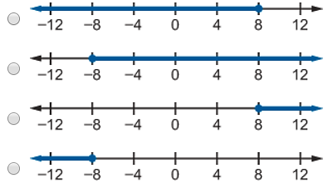
A.

B.

C.

D.

Example Alt Text:

- Four number lines are shown. Each number line goes from negative twelve to positive twelve. The first number line shows a point filled in at positive eight. The number line is shaded to the left of positive eight.

- There is a point filled in at negative eight. The number line is shaded to the right of negative eight.

- There is a point filled in at positive eight. The number line is shaded to the right of positive eight.

- There is a point filled in at negative eight. The number line is shaded to the left of negative eight.

Number Lines – Skip Counting

Description of Image: Number lines are visual representations of real numbers on horizontal or vertical lines marked at equal intervals. Number lines can use whole numbers, fractions, and/or decimals to model number relationships and the four operations with numbers.
General Considerations:
- Provide the title and/or x-axis label if present.
- Describe the number line by providing the range of numbers and scale if necessary.
- If a number line uses negative values, specify whether the value is negative or positive when providing the range.
- Specify where the counting begins and the number of skips shown. However, do not give the number of skips if doing so violates the construct being measured.
- Explain how the lines and/or arrows skip or jump.

Example Alt Text:
Charlie makes this number line to help solve a problem.

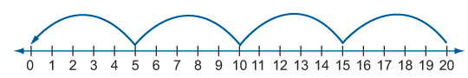

Which problem is Charlie trying to solve?
A. 20 - 4
B. 20 $×$ 4
C. 20 $÷$ 5
D. 20 - 5

Example Alt Text:

A number line is shown. The number line goes from zero to twenty. An arrow on the number line starts at twenty and skips four times. From twenty to fifteen, from fifteen to ten, from ten to five, and from five to zero.

Patterns

Description of Image: Patterns use shapes, numbers, or other objects to represent repeated reasoning or mathematical rules that organize these objects in a special way.
General Considerations:
- Provide an overview of what the pattern shows and explain how the pattern is arranged.
- Do not describe the color of the objects unless it is pertinent to the pattern.
- Use the vocabulary from the stem or question if possible.

Example Alt Text:
Adrian draws this shape pattern.
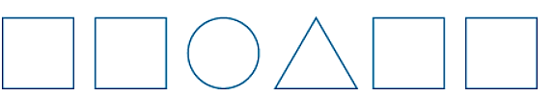

What two shapes does he draw next?
A. square, square
B. circle, circle
C. circle, triangle
D. triangle, square

Example Alt Text:
The pattern shows a row of shapes. There are two squares, one circle, one triangle, two squares.

Picture Graphs

Description of Image: Picture graphs (also known as pictographs) are pictorial displays that use symbols, icons, or pictures to represent categorical and numerical data.
General Considerations:
- Provide the title of the graph if present.
- Give a general description of what the picture graph shows and then explain the key.
- Insert the word picture after stating the name of the object given in the key (e.g., “one apple picture”).
- Use the key to describe the actual data for each category.
- Only include the colors of the objects when it is necessary for problem solving.
- Do not script when the expectation is to find the value of a single category.
- If construct violates the content being measured, script as, “A picture graph is shown.”

Example Alt Text:
The picture graph shows the number of basketball games that Kyle plays each month.

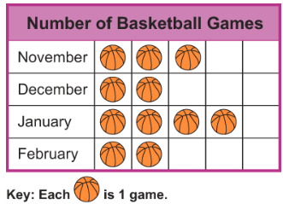

How many games does Kyle play in November and February?
A. 3
B. 4
C. 5

Example Alt Text:
The picture graph is titled Number of Basketball Games. The picture graph shows the names of some months and pictures of basketballs. A key shows one basketball picture is one game. November, three basketball pictures. December, two basketball pictures. January, four basketball pictures. February, two basketball pictures.

Rulers

Description of Image: A ruler is sometimes visually presented as a tool used to measure objects in inches, feet, yards, millimeters, or centimeters.
General Considerations:
- Describe the ruler and the units being measured.
- If the ruler contains fractional units, describe how the ruler is divided (e.g., “Marks divide the space between each number into fourths.”).
- Give the start and endpoint of the image being measured.
- If the object being measured beings at zero, the item cannot be scripted due to visual bias.
- If two objects are being measured to make a comparison, provide a separate script for each object.
- If the object being measured falls between two numbers on the ruler, give the approximate location and specify that it is an estimate.

Example Alt Text:
How many inches long is the toy train?
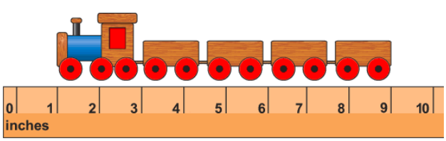

A. 8
B. 9
C. 10

Example Alt Text:
A toy train measured with an inch ruler is shown. The toy train begins as one inch and ends at nine inches.

Scales

Description of Image: A scale is sometimes visually presented as a device used to measure the weight or mass of objects.
General Considerations:
- Provide a brief description of what is being measured.
- Give the range of numbers, intervals if necessary, and units that are shown on the scale.
- If the measurement falls between two numbers, give the approximate location of the measurement and specify that it is an estimate.
- If the expectation is to read the values on the scale, the item cannot be scripted due to visual bias.

Example Alt Text:
Rosa measured a bag of apples on a scale, as shown below.
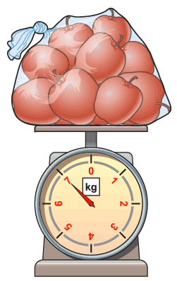

How many kilograms of apples did Rosa have left if she used 3 kilograms of the apples to make a pie?
A. 3
B. 4
C. 7

Example Alt Text:
How many kilograms of apples will Rosa have left if she uses 3 kilograms of the apples for the pie?
A. 3
B. 4
C. 7

A bag of apples is shown on a scale. The scale goes from zero kilograms to seven kilograms. An arrow points to the number seven on the scale.

Scatter Plots

Description of Image: A scatter plot is a statistical graph used to show the relationship between two variables of a data set plotted as points on a coordinate plane. Scatter plots usually deal with a large data set which can be analyzed to determine the correlation between the two variables.
General Considerations:
- Provide the title first, followed by the x-axis label, range, and scale. Then give the y-axis label, range, and scale.
- Give a brief description of the arrangement of the points by describing the correlation and pattern (e.g., concentrated, loosely scattered, spread out, upward trend, downward trend, etc.).
- If the scatter plot has a line of best fit, describe its position in relationship to the points (i.e., how many points are above, on, or below the line) or by giving the slope of the line.
- If less than eight points are shown, describe the individual points as long as it does not cause a cognitive overload.
- If construct violates the content being measured, script as, “A scatter plot is shown.”
Example Alt Text 1:
The income generated by a T-shirt shop in the first five years of operation is shown in the graph.

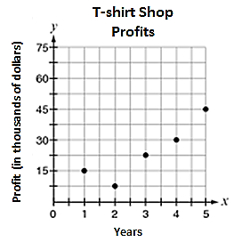

If the manager of the shop uses a line of best fit to predict the shop’s future income, what is the BEST prediction for the income in year 7?

Example Alt Text:
The scatter plot is titled T-Shirt Shop Profits. The x-axis is labeled Years and ranges from zero to five by a scale of one. The y-axis is labeled Profit in thousands of dollars and ranges from zero to seventy-five by a scale of fifteen thousand dollars. There are five points plotted on the graph. Year one, fifteen thousand dollars. Year two, seven thousand five hundred dollars. Year three, twenty-two thousand five hundred dollars. Year four, thirty thousand dollars. Year five, forty-five thousand dollars.

Scatter Plots (Cont.)

Example Alt Text 2:
The graphs below show data for four similar vegetable gardens. Which graph can be used to find the most accurate estimate of the number of vegetables the garden will yield if 100 seeds are planted?

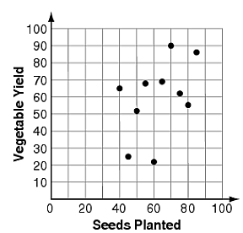
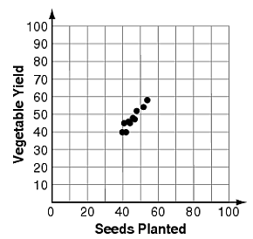

A. C.

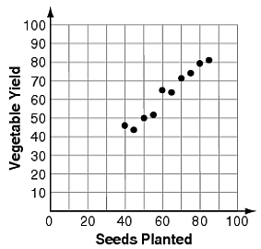
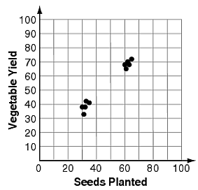

B. D.

Example Alt Text:
A. Four scatter plots are shown. The x-axis in each scatter plots is labeled Seeds Planted and ranges from zero to one hundred by a scale of twenty. The y-axis in each scatter plot is labeled Vegetable Yield and ranges from zero to one hundred by a scale of ten. Points are loosely scattered all over the first graph.
B. Points on the graph show an upward trend.

C. Points are tightly concentrated in an upward trend towards the middle of the graph.

D. Points are tightly concentrated in two separate sections on the graph.

Spinners

Description of Image: Spinners are typically circles that are sectioned off into different parts or categories. Spinners are used to calculate the chance or probability of a given outcome in a mathematical experiment.
General Considerations:
- Describe how the spinner is divided, including the number and relative size of the sections (i.e., whether the sections are equal or unequal).
- If the sections are equal, read the letters, words, or numbers on each section in a clockwise direction starting at the noon hour in relation to a clock.
- If the sections are unequal, list the sections from largest to smallest.
- Only include information from the stem in the script if additional clarity is needed to accurately describe the spinner.

Example Alt Text:
The spinner below is divided into sections that are red, green, or blue.

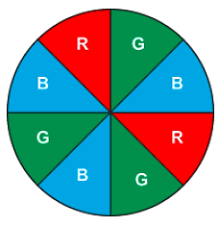

What is the probability that the spinner will land on red?
A. 0
B. $\frac{1}{4}$
C. $\frac{3}{8}$
D. 1

Example Alt Text:
A circular spinner divided into eight equal sections is shown. A letter that stands for each color is written in each section. The sections are labeled G, B, R, G, B, G, B, R.

Tables

Description of Image: Tables are visual displays used to collect and organize data in rows and columns.
General Considerations:
- Provide the title and the total number of rows and columns.
- Give the column headers from left to right or the row headers from top to bottom.
- Use the table headers to describe the data for each table entry.
- Always include units of measure or headers when explaining the data.

Example Alt Text:
The table below shows the sale prices of chicken at four wholesalers.
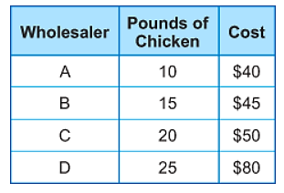
Sale Prices of Chicken

Which wholesaler has the best price on chicken?
A. wholesaler A
B. wholesaler B
C. wholesaler C
D. wholesaler D

Example Alt Text:

The table is titled Sale Prices of Chicken. The table has three columns and four rows. The first column is labeled Wholesaler, the second column is labeled Pounds of Chicken, and the third column is labeled Cost. Wholesaler A, ten pounds of chicken, forty dollars. Wholesaler B, fifteen pounds of chicken, forty-five dollars. Wholesaler C, twenty pounds of chicken, fifty dollars. Wholesaler D, twenty-five pounds of chicken, eighty dollars.

Tally Charts

Description of Image: A tally chart is a table used to record the frequency and distribution of data using tally marks instead of numbers.
General Considerations:
- Provide the title and column or row headers if present.
- If there are no column or row headers, briefly explain what is shown in the tally chart.
- Describe the data for each table entry by identifying the category and the total number of tally marks.
- Do not give the total number of tally marks when the expectation is to read the tally chart. Instead, refer to the tally marks as a group (e.g., “one group of five,” “one group of two,” etc.).
- If construct violates the content being measured, script as, “A tally chart is shown.”

Example Alt Text:
Jane asked her friends which exercise they like best. She made this chart to show the answers.

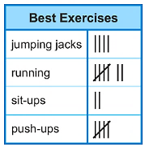

How many more friends like running better than doing push-ups?
A. 2
B. 3
C. 5

Example Alt Text:

The tally chart is titled Best Exercises. It shows four exercies in the first column and the number of friends that like each exercise in the second column. Jumping jacks, four. Running, seven. Sit-ups, two. Push-ups, five.

Thermometers

Description of Image: A thermometer is sometimes visually presented as an instrument used to measure temperature or to model the relationship between positive and negative numbers.
General Considerations:
- Provide the range of numbers, intervals if necessary, and units that are shown on the thermometer.
- Specify the temperature by giving the mark at which the liquid stops.
- If the measurement falls between two numbers, give the approximate location of the measurement and specify that it is an estimate.
- If the expectation is to read the values on the thermometer, the item cannot be scripted due to visual bias.

Example Alt Text:
What is the opposite of the temperature shown on the thermometer in degrees Fahrenheit ( °F)?

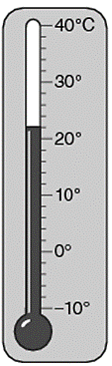

A. 8°F
B. 0°F
C. –8°F
D. –10°F

Example Alt Text:

A thermometer is shown. It goes from negative ten to positive forty degrees Fahrenheit. Marks are shown at every two degrees. The liquid stops at the mark before positive ten.

Venn Diagrams

Description of Image: Venn Diagrams are visual representations used to compare and show the relationships between different of sets of objects, concepts, data, etc.
General Considerations:
- Give a brief description of what the Venn diagram shows by using the term overlapping circles.
- Specify the title and any labels if present.
- Focus on explaining the data in the diagram, not its appearance.
- Only describe content that is necessary for problem solving.
- Do not script if doing so will violate the construct being measured or cause a cognitive overload.

Example Alt Text:
The Venn diagram below compares the attributes of different quadrilaterals.

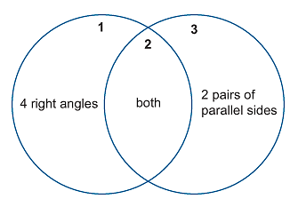

Write the correct number in the box that matches the section of the Venn diagram where each shape should be placed.

square:

rhombus:

Example Alt Text:

A Venn diagram is shown. There are two overlapping circles titled one and three. Circle one is labeled four right angles. Circle three is labeled two pairs of parallel sides. The area of overlap is titled two and is labeled both.

Vertical Equations

Description of Image: Equations are sometimes presented vertically so that place value understanding can be established when performing any of the four operations with numbers.
General Considerations:
- Give the equation as a number sentence.
- In equations with more than one term, use plus, minus, times, or divided by after each term.
- Use equals for the bottom bar in addition, subtraction, and multiplication equations. Use equals after giving the divisor in a division equation.
- If construct violates the content being measured, script as, “A vertical equation is shown.”

Example Alt Text 1: Example Alt Text 2:
Erick’s family picks 386 berries. They eat 35 of the berries. How many berries do they have left?

What is the sum?

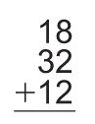
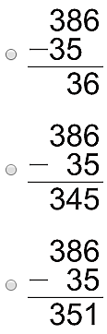
A.

B.

C.

A. 52
B. 60
C. 62

Example Alt Text 1: Example Alt Text 2:
- A vertical equation shows three
hundred eighty-six minus thirty-five
equals thirty-six.

- A vertical equation shows three
hundred eighty-six minus thirty-five
equals three hundred forty-five.

- A vertical equation shows three
hundred eighty-six minus thirty-five
equals three hundred fifty-one.

Eighteen plus thirty-two plus twelve equals how many?

How to Author Alt Text in CMS/Learnosity

Multiple Choice Items and Most TEIs:
- Open the editing page for the item and click on the pencil found on the right-hand side of the screen.
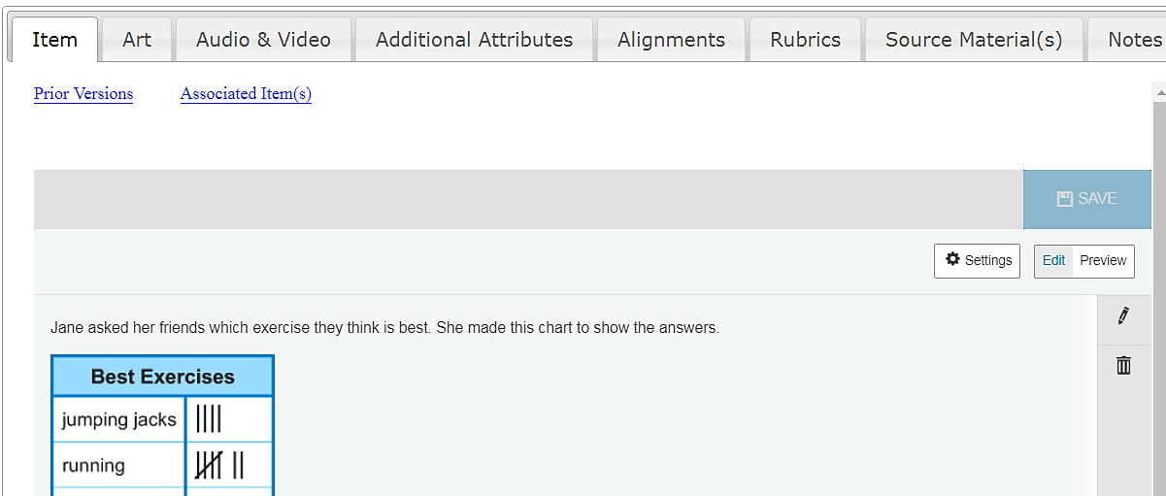

- On the new editing screen, locate all the places in the stem and distractors where an image is present. Click on an image and hit Edit when the pop-up window appears.
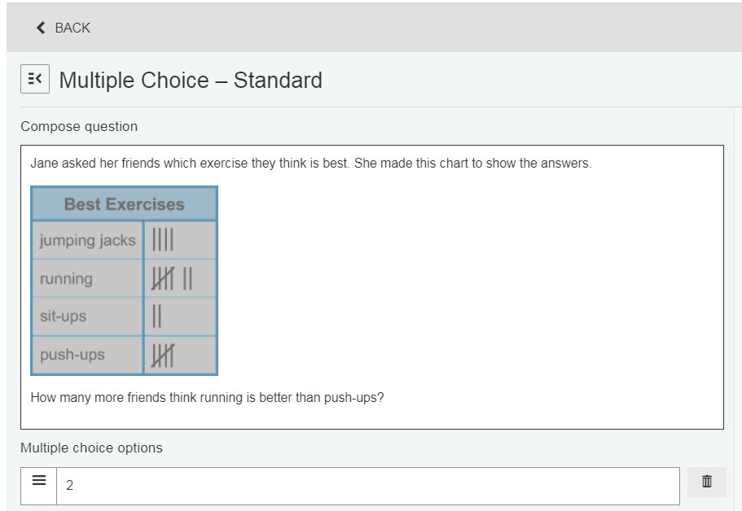

Edit

- An art editing window will appear. Enter the actual script in the Alternative Text field. After the script has been entered, click OK.
Note: A script can be cut and paste from another document as long as it does not include any special characters or symbols.
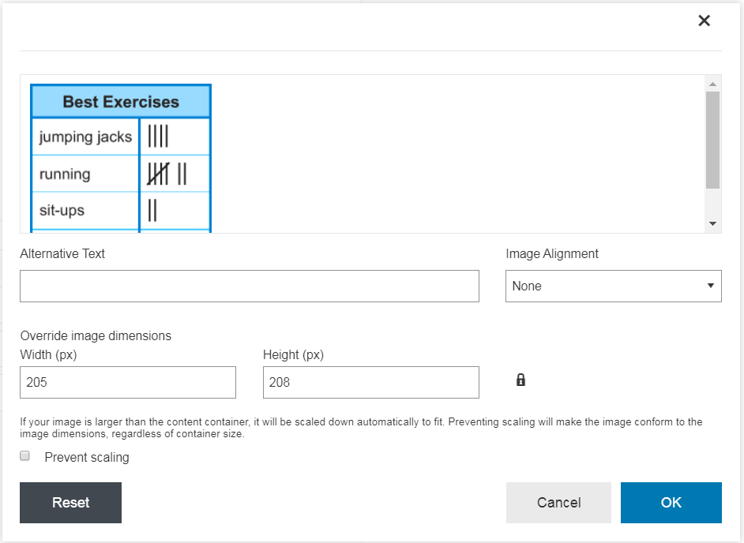

- When alt text has been added for all images within an item, click Save at the top of the item editing screen. The Save button will turn green and you will get a notification that the item has been saved successfully.
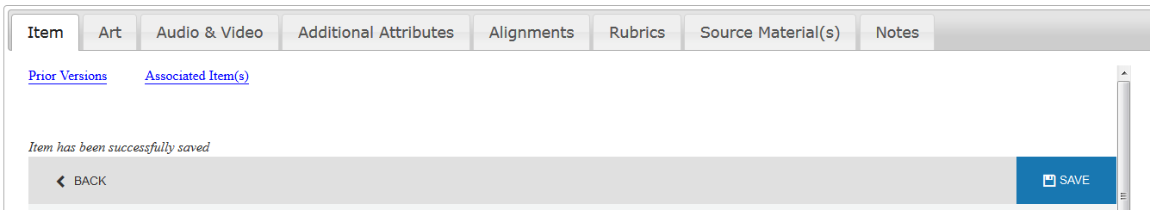

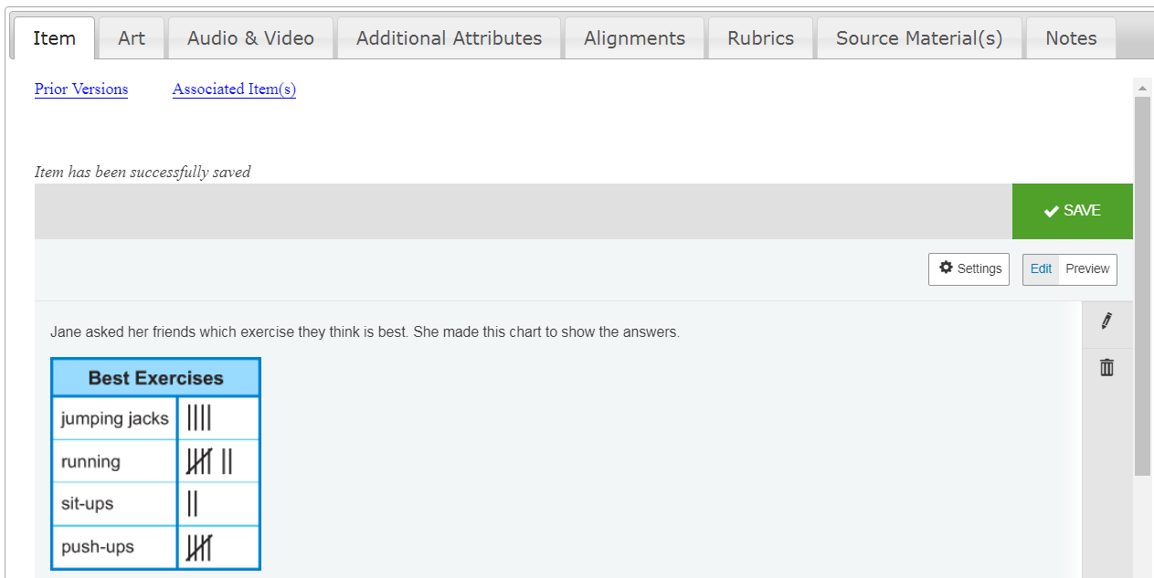

How to Author Alt Text in CMS/Learnosity (Cont.)

Special Case TEIs Templates:
- Enter Math – Image Cloze Math Formula
- Fill-in-the-Blank – Label Image (Drag & Drop and Drop Down)
- Hotspot
- Shading

- The process for entering script for these TEI templates is the same, except for the location of the Alternative Text field.

- Instead of clicking on the image to open an art editing window, simply enter the script in the Image Alternative Text that appears to the right of the image.

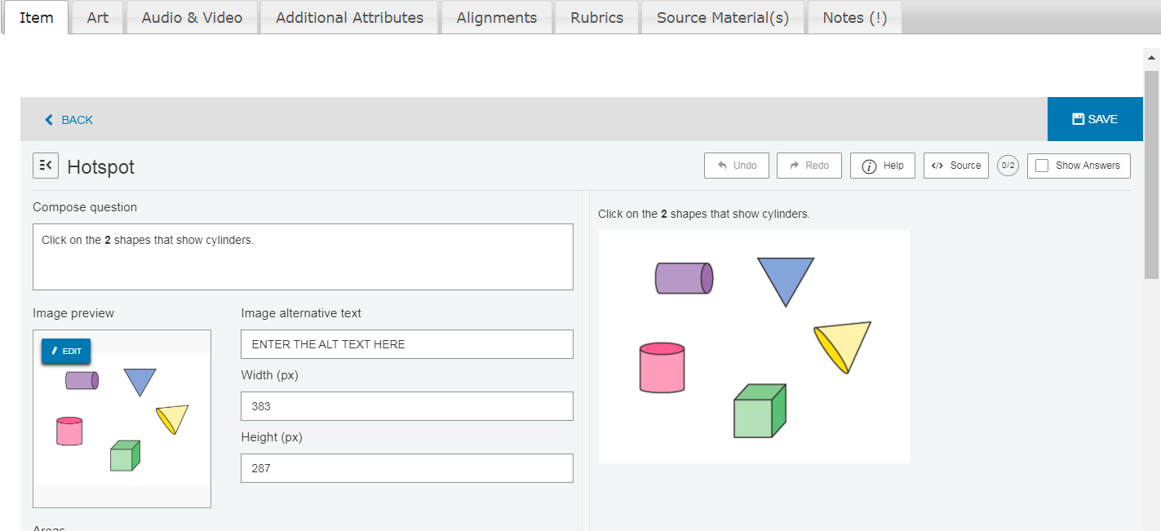
- Then click Save at the top of the editing screen.

How to Author Alt Text in Habitat

Static Image Patterns:
- To enter text alternatives for an image in Habitat, select the image and then click “Change Image” in the panel that appears.
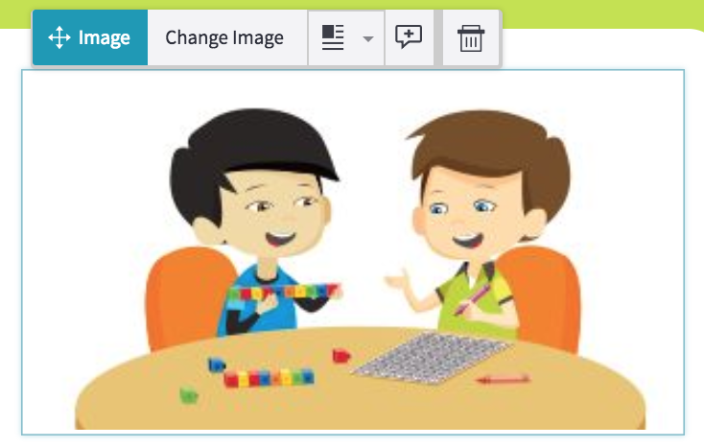
- An Edit Image box will pop up. You can enter the text alternatives in the “Enter alternative text for image” box and then click on “Done.”
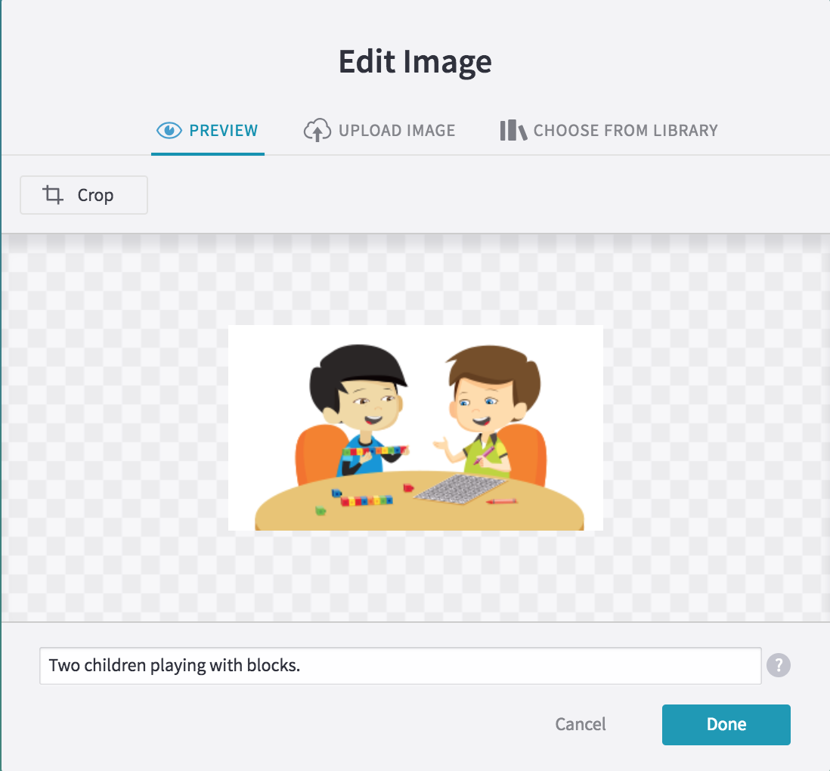

Tip: Due to space constraints in the text entry field, you may find it helpful to initially write your text alternatives in an editing tool and then paste it into Habitat. However, please note that pasting in special formatting (e.g. bold, ital) from tools such as Word or Excel can cause text display problems in Habitat. It is recommended that you use a plain text editor like notepad (Windows) or TextEdit (Mac). If you must use Word or Excel, avoid using special characters and be mindful of the issues that can arise.

Interactive Patterns (Widgets):
- Select the widget and click “Edit Widget” in the panel that appears. The authoring interface will open.
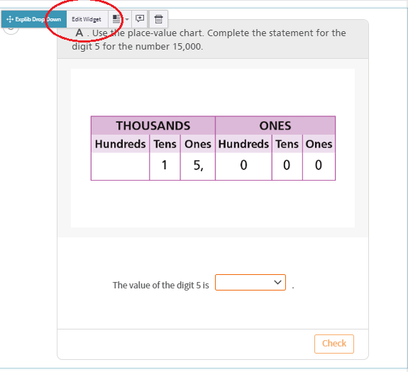
- When it opens you will see 2 types of Alt Text fields:
- Summary Alt Text
- Image Alt Text field or fields
The “Summary Alt Text” field in the Set-Up Area allows for a description of the whole interaction. This should NOT be used for Image alt text.
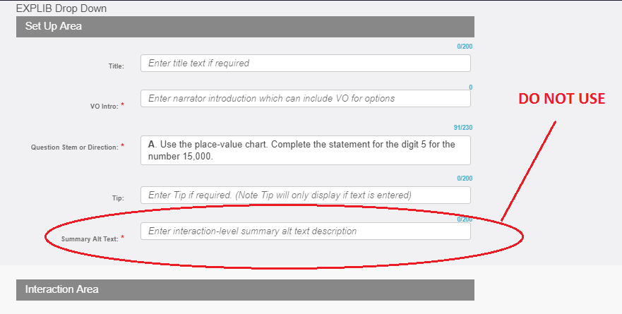

The “Alt Text” field next to the image itself is where you should add alt text. Each image will have its own Alt Text field, and if an image is added the field will also be added.
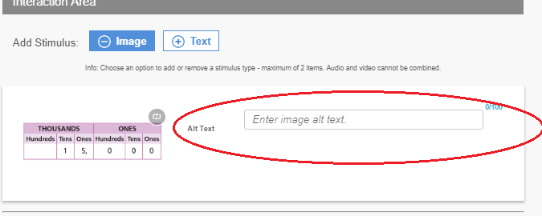
Add your image alt text to the field as plain text, then save and close the widget.

Embedded Math Notation

The following specifications are a general guide for instances where a number, equation, operation, or symbol is embedded within an image. These best practices provide an additional guide for authoring alternative text.

- Scripts for Numbers

  - Decimals
  - Use and between the whole number and decimal.
  - Use point and list each individual digit separately when an item is assessing place value.
  - Use repeating when a bar appears over a digit(s).

  - Example: 4.32 min. should be scripted as, “Four and thirty-two hundredths minutes.”

  - Example: $0.\overline{7}$ should be scripted as, “Seven tenths repeating.”

  - Fractions and Mixed Numbers
  - Use a two word description for proper and improper fractions with a numerator and/or denominator less than or equal to 20.

  - Use a fraction with numerator ___ and denominator ___ for proper and improper fractions with a numerator and/or denominator greater than 20.

  - Use and between the whole number and fraction in a mixed number. The same considerations above should be used for scripting the fraction portion of the mixed number.

  - Do not script shortcuts for common fractions (e.g., a half, three-quarters, etc.).
  - Example: $\frac{1}{4}$ should be scripted as, “One fourth.”

  - Example: $\frac{50}{6}$ should be scripted as, “A fraction with numerator fifty and denominator six.”
  - Example: $8\frac{3}{12}$ should be scripted as, “Eight and three twelfths.”

  - Large Numbers
  - Use the proper written name for all large numbers given in standard form.
  - List each individual digit separately when an item is assessing place value.
  - Do not include the word and in numbers over one hundred.

  - Example: 65,029 should be scripted as, “Sixty-five thousand, twenty-nine.”

  - Example: 107,384 used in an item that assess place value should be scripted as, “One zero seven comma three eight four.”

  - Negative Numbers
  - Use negative instead of a hyphen, en-dash, or minus sign.
  - Use the opposite of for a negative sign that appears outside a set of parentheses that contain a standalone value, variable, or equation.

  - Example: –5 should be scripted as, “Negative five.”

  - Example: –(–4) should be scripted as, “The opposite of negative four.”

  - Example: –(–x + 2) should be scripted as, “The opposite of, open parenthesis, negative x plus two, closed parenthesis.”

- Scripts for Equations and Operations

  - Addition
- Use plus for the addition symbol (+).

- Example: 6 + 3 = 9 should be scripted as, “Six plus three equals nine.”

  - Absolute Values
  - Use absolute value of for the absolute value sign (| |).

  - Example: $\left|-12+8\right|$should be scripted as, “The absolute value of negative twelve plus eight.”

  - Division
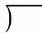
  - Use divided by for division symbols (÷ and ).

  - Example: 10 $÷$ 2 = 5 should be scripted as, “Ten divided by two equals five.”

  - Equal Sign
  - Use equals for the equal symbol (=).

  - Example: 4 = 4 should be scripted as, “Four equals four.”

  - Exponential Notation
  - Give the base first followed the exponent.
  - Exponents with a value of two or three can be read as cubed and squared.

  - Example: $y=x^{2}$ should be scripted as, “Y equals x squared.”

  - Example: $6^{8}$ should be scripted as, “Six to the eighth power.”

  - Example: $y=3^{x+2}$ should be scripted as, “Y equals three to the x plus two power.”

  - Multiplication
  - Use times for multiplication symbols (⨯ and ·).

  - Example: 5 ⨯ 3 = 15 should be scripted as, “Five times three equals fifteen.”

  - Parentheses and Brackets
  - Use open parenthesis and closed parenthesis for ( ) and [ ].

  - Example: 2(x + y) = 10 should be scripted as, “Two, open parenthesis, x plus y, closed parenthesis, equals ten.”

  - Subtraction
  - Use minus for the subtraction symbol (–).

  - Example: 9 – 3 = 6 should be scripted as, “Nine minus three equals six.”

  - Variables
  - Only specify a variable’s case when both lowercase and uppercase variables appear together in the same item.
  - Use opposite of when a negative sign appears before a variable.

  - Example: –a + b = 17 should be scripted as, “The opposite of a plus b equals seventeen.”

- Scripts for Symbols

  - Angles and Triangles
  - Use angle and triangle for each symbol (∠ and ∆) or when describing these actual figures.
- Only specify a letter’s case when both lowercase and uppercase letters appear together in the same item.
- Name angles by three points when possible making sure the vertex of the angle is the middle letter.
- Name triangles by the vertices in a clockwise direction around the figure.
- Insert a space between each letter in the name of the angle or triangle.

  - Example: ∠DEF (with E for the vertex) should be scripted as, “Angle D E F.”

  - Example: ∆RST should be scripted as, “Triangle R S T.”

  - Abbreviations
  - Use the actual word for an abbreviation unless doing so violates the construct being measured.

  - Example: 25 in. should be scripted as, “Twenty-five inches.”

  - Blank Boxes and Lines
  - Use blank for a blank box or line ( □ or ___ ).

  - Insert a comma to create a pause after the word blank.
  - Example: 13 + □ = 19 should be scripted as, “Thirteen plus blank, equals nineteen.”

  - Ordered Pairs
  - Use comma instead of the symbolic representation.
  - Example: Point A (–9, 3) should be scripted as “Point A is at negative nine comma three.”

  - Inequalities
  - Use less than and greater than for the symbols $<$and $>$.
  - Use less than or equal to and greater than or equal for the symbols $≤$ and$≥$.
  - Use is not equal to for the symbol $≠$.
  - When more than one symbol appears in the same inequality, use a comma and which is before the second symbol.

  - Example: 8 $>$ –4 should be scripted as, “Eight is greater than negative four.”

  - Example: w $≤$ x $<$ y should be scripted as, “W is less than or equal to x, which is less than y.”

  - Line Segments, Rays, and Lines
  - Use line segment, ray, or line for these symbolic representations that appear above letters or numbers.
- Insert a space between each letter in the name.

  - Example: $\overline{CD}$ should be scripted as, “Line segment C D.”

  - Example:$\vec{PQ}$ should be scripted as, “Ray P Q.”

  - Example: $\overset{⃡}{JK}$ should be scripted as, “Line J K.”

  - Money Symbols
  - Use dollars for the dollar sign ($) and cents for the cents sign (¢).
  - Use and for the decimal point when dollars and cents are given.
  - Do not identify the coin as a shortcut for providing a written value.

  - Example: $3.91 should be scripted as, “Three dollars and ninety-one cents.”

  - Example: $0.25 should be scripted as, “Twenty-five cents.”

  - Measurements
  - Use the actual word for an abbreviated measurement unless doing so violates the construct being measured.

  - Example: 8' or 8 ft should be scripted as, “Eight feet.”

  - Example: 64 cm³ should be scripted as, “Sixty-four cubic centimeters.”

  - Parallel and Perpendicular Lines
  - Use is parallel to for the symbol ‖.
  - Use is perpendicular to for the symbol ⟘.
  - Example: $\overset{⃡}{AB}$ ‖ $\overset{⃡}{DE}$ should be scripted as, “Line A B is parallel to line D E.”

  - Example: $\overline{LM}$ ⟘ $\overline{NT}$ should be scripted as, “Line segment L M is perpendicular to line segment N T.”

  - Probability
  - Use the probability of for the symbol P.
  - Do not include open parenthesis or closed parenthesis.
  - Use is instead of equals for the equal sign.
  - Example: P(blue) = $\frac{1}{4}$should be scripted as, “The probability of blue is one fourth.”

  - Temperature
  - Use degrees Fahrenheit for the symbol$℉$.
  - Use degrees Celsius for the symbol $℃$ .
  - Use point when the temperature contains a decimal value.

  - Example: 72°F should be scripted as, “Seventy-two degrees Fahrenheit.”

  - Example: 40.5°C should be scripted as, “Forty and five tenths degrees Celsius.”

  - Transformations
  - Use prime when scripting the prime notation transformed or reflected angles.
- Only specify a letter’s case when both lowercase and uppercase letters appear together in the same item.
- Name all figures by the vertices in a clockwise direction around the figure.

  - Example: ∆A'B'C' should be scripted as, “Triangle A prime B prime C prime.”

  - Time
  - See the section on Clocks for specifics on scripting analog and digit clocks.
  - Use the spoken time if doing so does not violate the construct being measured.
  - Do not script shortcuts for common times (e.g., noon, ten after five, etc.).

  - Example: 6:45 should be scripted as, “Six forty-five.”

3.14 Blank boxes in Tables
  - For each instance in a table, script using “blank”.
  - Insert a comma when appropriate following blank when appropriate.
  - When a table is art include description of text with the blanks in the table.

Contributions

The authors of this guide would like to acknowledge the many organizations that were helpful in creating the content procured within this document. The goal of providing highly accessible content and media at HMH could not have been authored without the leadership of the National Center for Accessible Media (NCAM), which has played a crucial role in addressing the barriers to technology for students with disabilities. NCAM brings an unparalleled level of expertise to the advancement of accessibility and has been a forerunner in paving the way for alternative testing strategies.
In addition to NCAM, Houghton Mifflin Harcourt extends its appreciation to the authors of the Guidelines for Accessible Assessments Project (GAAP) that were developed under an Enhanced Assessment Grant via the United States Department of Education. The GAAP document provides direction in the scripting and tagging of audio representation for Common Core assessement items.
Recommendations from the University of Kansas Audio Guidelines for Accessible Audio were utilized while compiling the best practices listed in this document. The University of Kansas provided important documentation related to audio scripting and tagging of computer-based delivery that helped to inform the decision-making process. Their standardized approach across thousands of items in adopting new processes and procedures shed light upon the best practices of implementing new strategies for acommodated learners at HMH.
Lastly, HMH authors would like to acknowledge the Northwest Evaluation Association (NWEA) which produced the Image Description Guidelines for Assesment. Their development of detailed text descriptions, especailly concerning art commonly used in math education, allows students to access subject material that might otherwise be inaccessible.
The contents of this document continue to grow as new technological advacements emerge and research is conducted to better understands the needs of unique learners. The current guidelines for scripting mathematics audio are a result of a collaborative effort among assessment and subject matter experts in various grade levels at HMH. They are not meant to be restrictive, but rather to enhanace the engagement level among all learners.

Additional Resources
https://www.wgbh.org/foundation/what-we-do/ncam

